Cherry Hill HS East and Rosa International Middle School
Bridge Tutoring & Mentoring
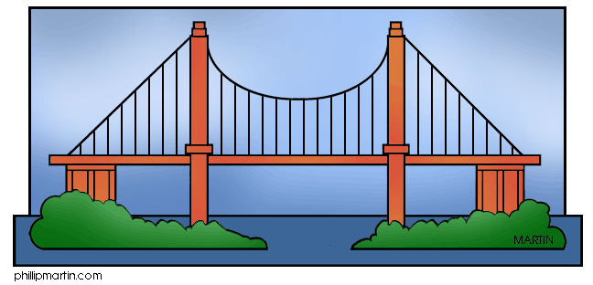
The Bridge Tutoring & Mentoring Program meets afterschool most Mondays and Wednesdays in lower B-wing. Cherry Hill East high school volunteers are available to help Rosa’s 6th, 7th and 8th graders with their homework in all subjects and at all levels. They can provide help for study groups. Additionally, tutors can help students organize their binders and lockers. They can also offer some advice and encouragement when it comes to maintaining homework planners.
Bridge is especially important to our eighth graders who will soon be entering high school. East tutors bridge the gap between middle school and 9th grade by sharing their experiences about high school electives and how to manage their time. Those aspiring to take advanced classes in high school will benefit from the first -hand knowledge of the Bridge tutors, many of whom are in Honors level classes.
Students work approximately one hour with a tutor, either individually or in small group. This is followed by a 20-25 minutes “rap” sessions, fun activities designed to “bridge the gap” between the middle school and high school years. Late busses are available for any student participating in this program. *Please refer to the Bridge 2015-2016 Schedule & FAQ for further details.
We hope that you will take advantage of Bridge and we look forward to seeing you.
Sincerely,
Mrs. Christine Lind & Mrs. Lillian Halden

Learning Community ________ Please return to your advisor: ________________________________
Student Name (Print): ____________________________________________________________________
Student Signature: _______________________________________________________________________
Parent/Guardian Name (Print): _____________________________________________________________
Parent/Guardian Signature: _______________________________________________________________
I am interested in attending Bridge:
____ Mondays & Wednesdays _____ Mondays only ____Wednesdays only
____ Occasionally

